**Question 1:**

1. **use a command to show the current working directory**

* root@Helios-300:/home/folder1# pwd

/home/folder1

* **list the directory contents in the short and long format**

root@Helios-300:/home/folder1# ls -l

total 4

-rwxrwxrwx 1 root root 91 Mar 10 12:17 file.txt

-rw-r--r-- 1 root root 0 Mar 9 11:05 file2.txt

* **list all files along with hidden files in the current working directory.**

root@Helios-300:/home/folder1# ls -a

. .. file.txt file2.txt

* **list only hidden files in the directory**

1. **Make a directory and name it as cdac-dir and change the current working directory to the new directory.**

root@Helios-300:/home# ls

cdac_kh folder1 folder3 folder4

root@Helios-300:/home# mkdir cdac-dir

root@Helios-300:/home# ls

cdac-dir cdac_kh folder1 folder3 folder4

root@Helios-300:/home# cd cdac-dir

root@Helios-300:/home/cdac-dir# pwd

/home/cdac-dir

1. **Create following nested directories inside the current directory by invoking a single command for only one time.**

mkdir -p abc/pqr/xyz

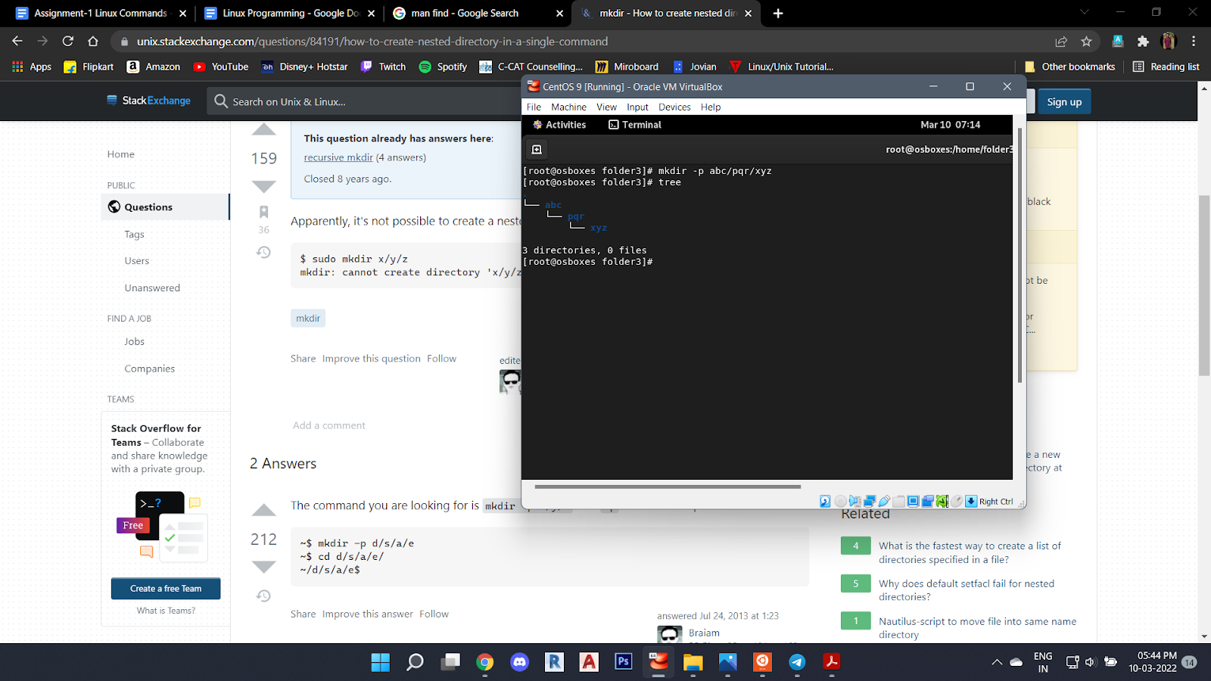

1. **List the directories(folders), then remove the cdac-dir directory and list the folders again to show that it is no longer present.**

root@Helios-300:/home# ls

cdac-dir cdac_kh folder1 folder3 folder4

root@Helios-300:/home# rmdir cdac-dir

root@Helios-300:/home# ls

cdac_kh folder1 folder3 folder4

root@Helios-300:/home#

**Question 2:**

1. **Display the man-page for ls , but redirect the output into temp.txt , then use the cat, less , and more commands to display the new file.**

root@Helios-300:/home# man ls >>temp.txt

root@Helios-300:/home# cat temp.txt

root@Helios-300:/home# less temp.txt

root@Helios-300:/home# more temp.txt

1. **Display the initial 10 lines and final 5 lines of temp.txt with the obvious Linux commands.**

root@Helios-300:/home# head -n 10 temp.txt

LS(1) User Commands LS(1)

NAME

ls - list directory contents

SYNOPSIS

ls [OPTION]... [FILE]...

DESCRIPTION

List information about the FILEs (the current directory by default). Sort entries alphabeti‐

root@Helios-300:/home# tail -n 10 temp.txt

Copyright © 2018 Free Software Foundation, Inc. License GPLv3+: GNU GPL version 3 or later

<https://gnu.org/licenses/gpl.html>.

This is free software: you are free to change and redistribute it. There is NO WARRANTY, to

the extent permitted by law.

SEE ALSO

Full documentation at: <https://www.gnu.org/software/coreutils/ls>

or available locally via: info '(coreutils) ls invocation'

GNU coreutils 8.30 September 2019 LS(1)

1. **Copy temp.txt to another directory and rename it there.**

root@Helios-300:/home# ls

cdac_kh folder1 folder3 folder4 temp.txt

root@Helios-300:/home# cp temp.txt /home/folder3

root@Helios-300:/home# cd folder3

root@Helios-300:/home/folder3# ls

temp.txt

root@Helios-300:/home/folder3# mv temp.txt new.txt

root@Helios-300:/home/folder3# ls

new.txt

1. **Display the number of lines, words and characters in file using Linux command**

root@Helios-300:/home/folder3# wc new.txt

229 948 8009 new.txt

root@Helios-300:/home/folder3# wc -m new.txt

7994 new.txt

root@Helios-300:/home/folder3# wc -w new.txt

948 new.txt

root@Helios-300:/home/folder3# wc -l new.txt

229 new.txt

(**-m:** count characters, **-w:** count words, **-l:** count lines)

1. **Use history command to display the last 10 commands used.**

root@Helios-300:/home# history | tail -n 10

26 cd cdac-dir

27 pwd

28 cd ..

29 tree

30 apt install tree

31 ls

32 rmdir cdac-dir

33 ls

34 history tail -n 10

35 history | tail -n 10

**Question-3.**

1. **Create a tar archive file of any directory present in your home directory.**

root@Helios-300:/home/folder1# ls

file.txt file2.txt

root@Helios-300:/home/folder1# tar -cf file.tar file.txt

root@Helios-300:/home/folder1# ls

file.tar file.txt file2.txt

* **list the contents of the archive file without extracting.**

root@Helios-300:/home/folder1# tar tf file.tar

file.txt

1. **Create a zip file of another directory.**

root@Helios-300:/home/folder4# ls

file.txt

root@Helios-300:/home/folder4# gzip file.txt

root@Helios-300:/home/folder4# ls

file.txt.gz

* **list the contents of the zip file without extracting.**

root@Helios-300:/home/folder4# zcat file.txt

This file is opened in Ubuntu.

Use zcat command to list contents of file.

1

2

3

4

5

The END

1. **Give read, write & execute permissions to your file.**

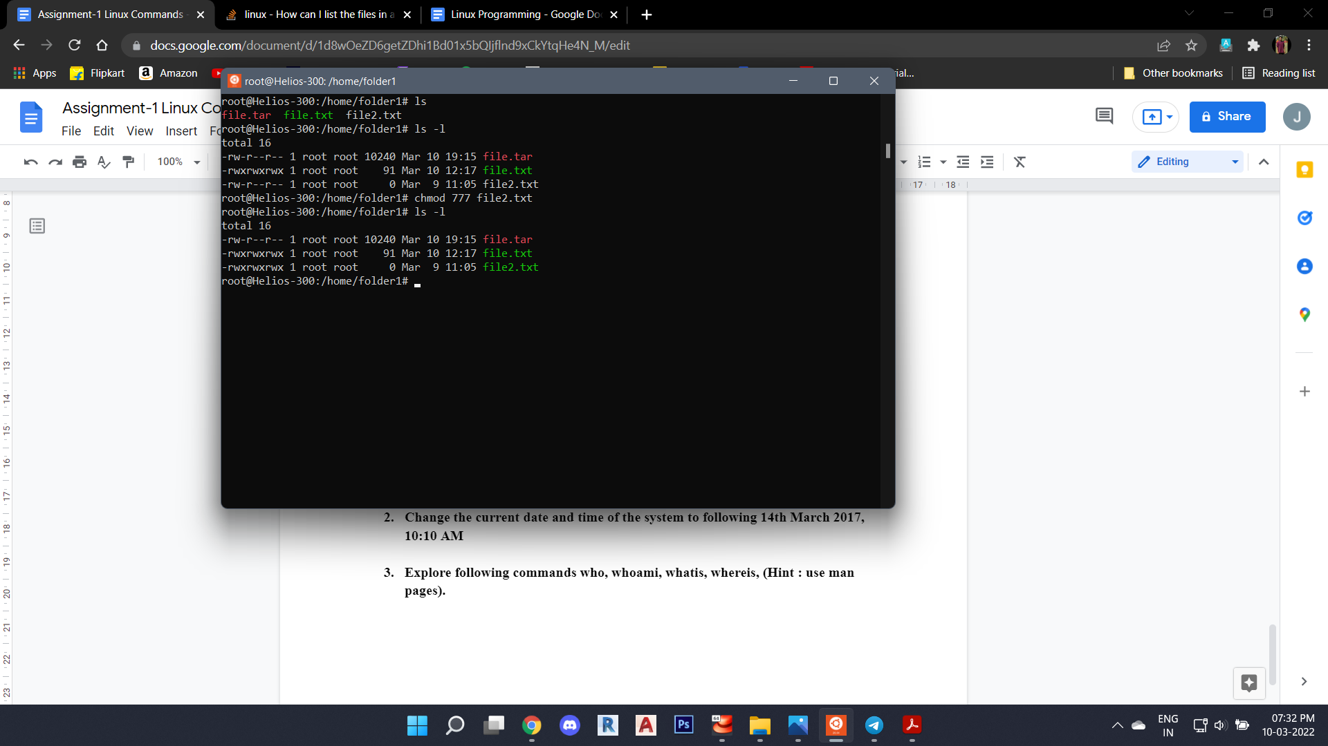

1. **Change ownership of that file.(Hint : use chown command)**

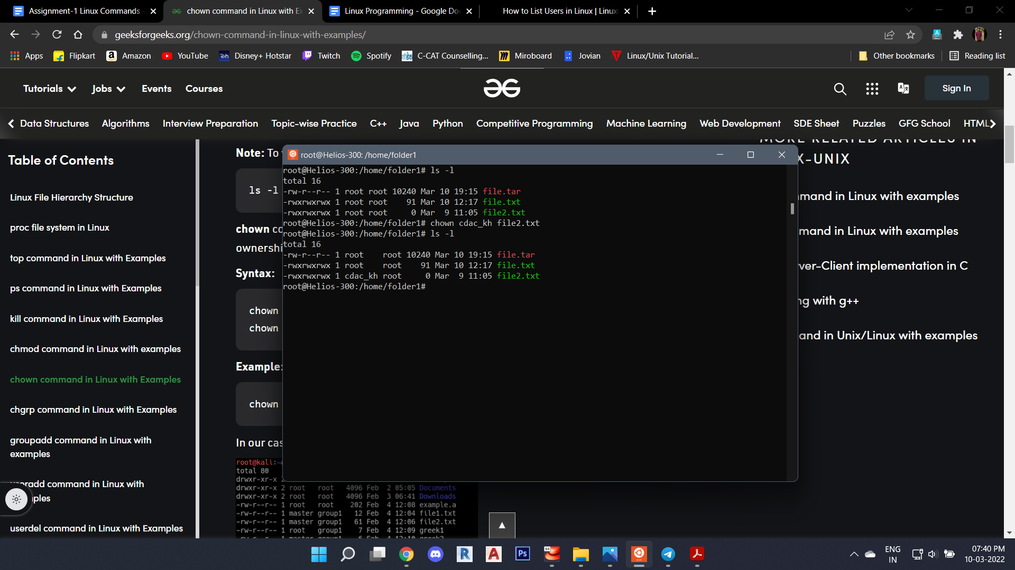

1. **List processes running in shell, all running processes and show top processes in decreasing order of their resource utilization.**

root@Helios-300:/home/folder1# ps

PID TTY TIME CMD

22 pts/0 00:00:00 sudo

23 pts/0 00:00:00 su

24 pts/0 00:00:00 bash

413 pts/0 00:00:00 ps

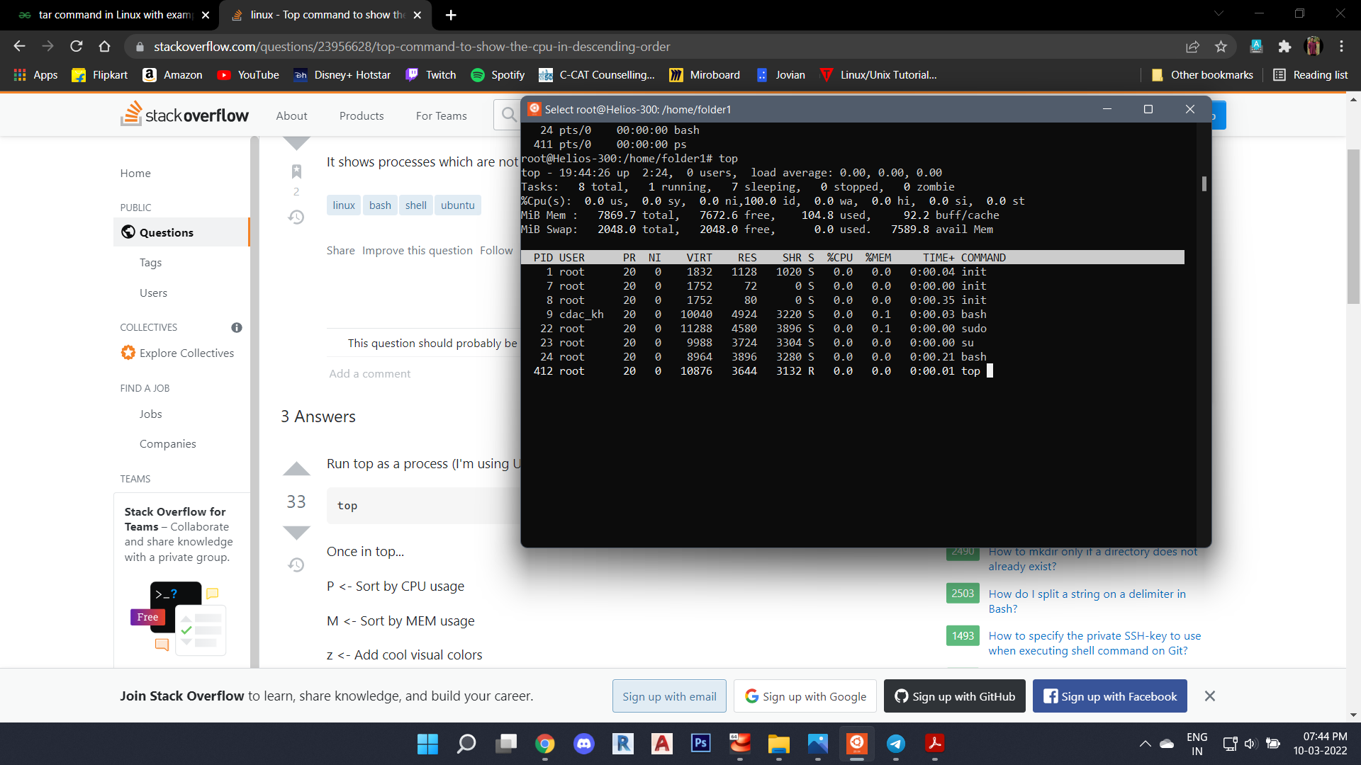

**Question-4.**

1. **Display current time and calendar (Hint : use date, cal commands)**

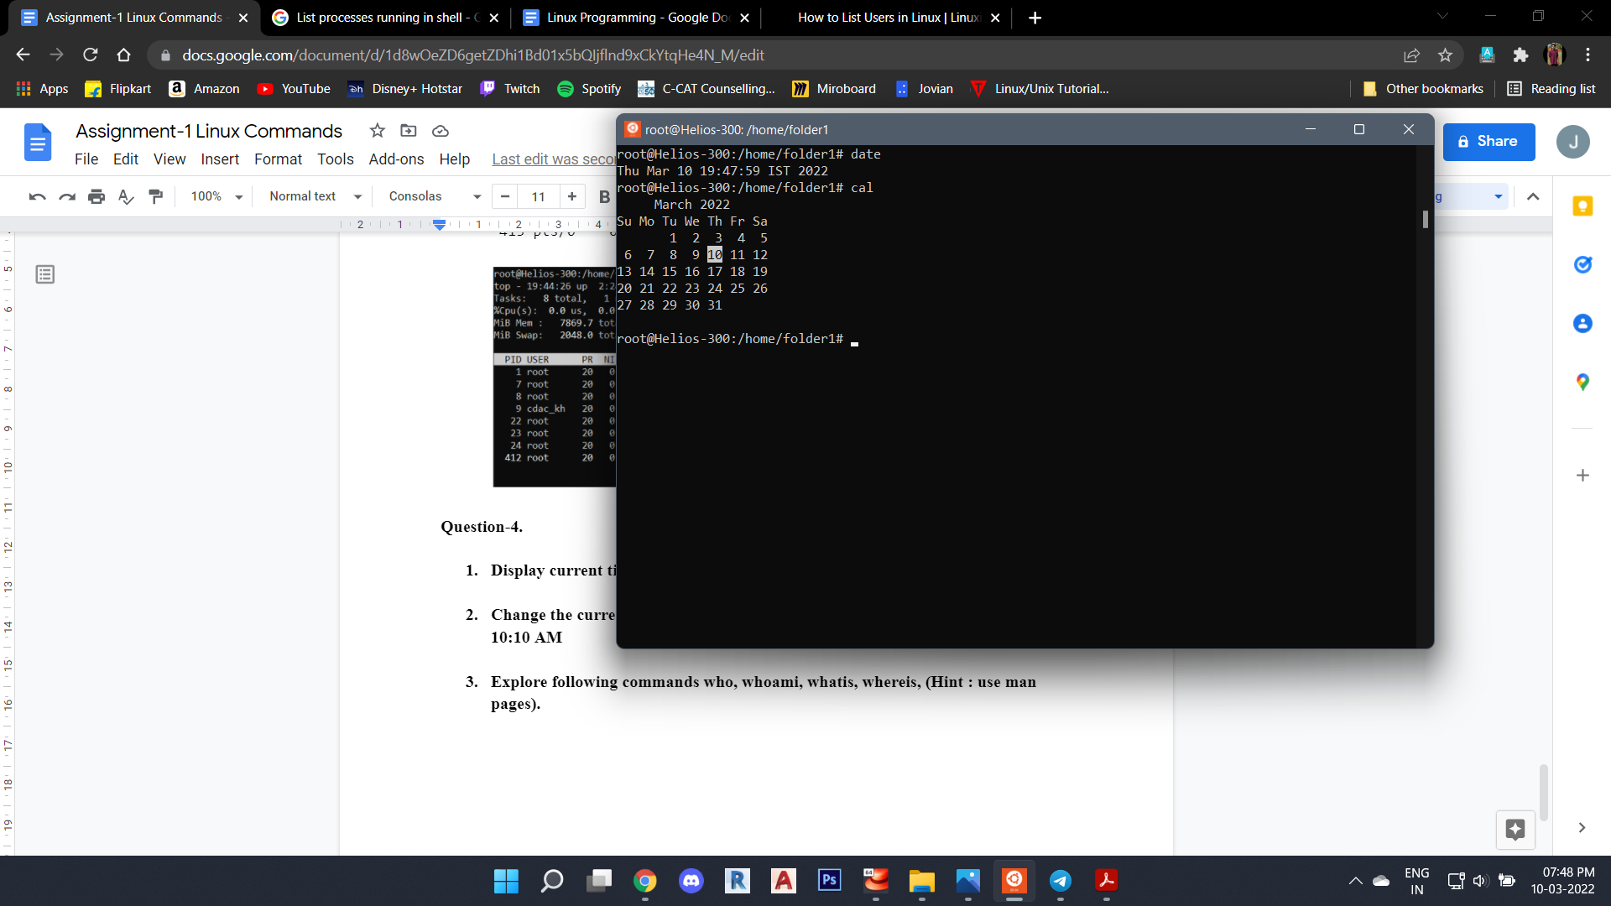

1. **Change the current date and time of the system to following 14th March 2017, 10:10 AM**

root@Helios-300:/home/folder1# date -s "14 MARCH 2017 10:10:00"

Tue Mar 14 10:10:00 IST 2017

root@Helios-300:/home/folder1# date

Tue Mar 14 10:10:08 IST 2017

1. **Explore following commands who, whoami, whatis, whereis, (Hint : use man pages).**

root@Helios-300:/home/folder1# whoami

root

root@Helios-300:/home/folder1# whatis ls

ls (1) - list directory contents

root@Helios-300:/home/folder1# whereis file.txt

file: /usr/bin/file /usr/lib/file /usr/share/file /usr/share/man/man1/file.1.gz